Report on Accident Circumstances
Note: Be sure to attach the Traffic Accident Certificate issued by the Japan Safe Driving Center.
Parties | A  (the other party) |  | Full name
Parties | B  (me) |  | Full name |  |  | □Driver □Passenger □Pedestrian  □Other（ ）
Speed | A’s car | km/h |  | B’s car | km/h | Road conditions | □Heavy  □Moderate  □Light traffic | □Good visibility  □Poor visibility
Please provide a drawing that shows the circumstances of the accident. | Drawing of the circumstances of the accident
  Indicate the road width in meters.
  ■A’s car
  □B’s car
  ◇A car other than A’s and B’ s
  ○Person
  ↑Direction of travel
  ◎Traffic light
  ⇒Direction of travel
Please write an explanation of the above drawing.

The accident details are as stated above and on the separately attached Traffic Accident Certificate.
On / / （MM/DD/YYYY)

Reporter Relationship with A（ ）
Relationship with B ( )
〒
Address

Full name (seal)
(Be sure to include your signature and seal.)

Entry Example
Report on Accident Circumstances
Note: Be sure to attach the Traffic Accident Certificate issued by the Japan Safe Driving Center.
Parties | A  (the other party) |  | Full name | Ichiro Kenpo
Parties | B  (me) |  | Full name | Hanako Kenpo |  | □Driver □Passenger □Pedestrian  ✔  □Other（ ）
Speed | A’s car | 40 km/h |  | B’s car | 30 km/h | Road conditions | □Heavy  ✔  □Moderate  □Light traffic | □Good visibility  ✔  □Poor visibility
Please provide a drawing that shows the circumstances of the accident. | 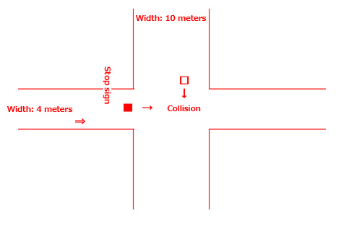  Drawing of the circumstances of the accident
  Indicate the road
  width in meters.
  ■ A’s car
  □B’s car
  ◇A car other than
  A’s and B’ s
  ○Person
  ↑Direction of travel
  ◎Traffic light
  ⇒Direction of travel
Please write an explanation of the above drawing. | While passing through an intersection in XX, YY City, A’s car (the other party) failed to stop at the stop line before entering the intersection, and then the front left part of A’s car collided with B’s car (us).

The accident details are as stated above and on the separately attached Traffic Accident Certificate.
On ○○/○○/○○ (MM/DD/YYYY)

Reporter Relationship with A（ ）
Relationship with B ( Husband )
〒000-0000
Address 1-1 XX, YY City, Tokyo
健保
Full name Taro Kenpo (seal)
(Be sure to include your signature and seal.)

